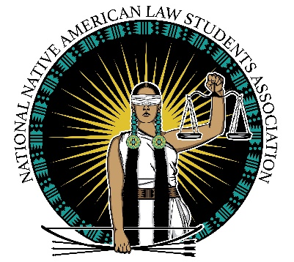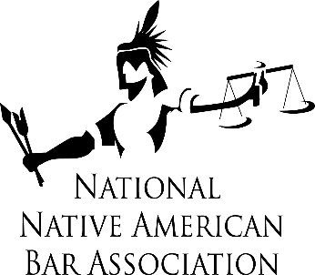

The National Native American Bar Association and National Native American Law Students Association Condemn the Exclusion of Native American Women Law Students from so-called “Women of Color” Law School Experiences Study by the Center for Women in the Law and The NALP Foundation

With the release of the “Women of Color” law school experiences study on June 16, 2020, the study organizers at the Center for Women in the Law and The NALP Foundation were contacted and received concerns from the Native American law community both by an online meeting and through a formal letter response dated June 26, 2020. The concerns focused on the exclusion of Native American women law students from the substance of the study. There were no charts, illustrations or qualitative representation of Native American women law students in the entire study. We explained this led to four primary issues with the study: 1) invisibility of Native law students; 2) lack of Natives in the planning of the study; 3) flaws in the methodology of the study; and 4) misrepresentations in the study due to failure to include Native American women as a group of women of color.

We requested a posted apology for the exclusion of Native American women law students; withdrawal of the study to incorporate the missing information on Native American women law students; and/or re-titling the study to reflect the limited information it portrayed from 46 self-selected law schools with only 4,000 responses from some women of color as the current title is misleading and overly broad. Rather than take any of the actions requested, the study organizers responded in defense of their product and took no responsibility for the harm leveled on the Native American Women law students and Native American Women in the legal field generally.

In unity, we have received supportive letters and statements from many diverse legal organizations and associations across the country. Due to this harm caused, we are shining a light on this example of exclusion and marginalization by these two organizations and request funding organizations and firms to reconsider supporting this type of research as evidenced in the June 16, 2020 study.

