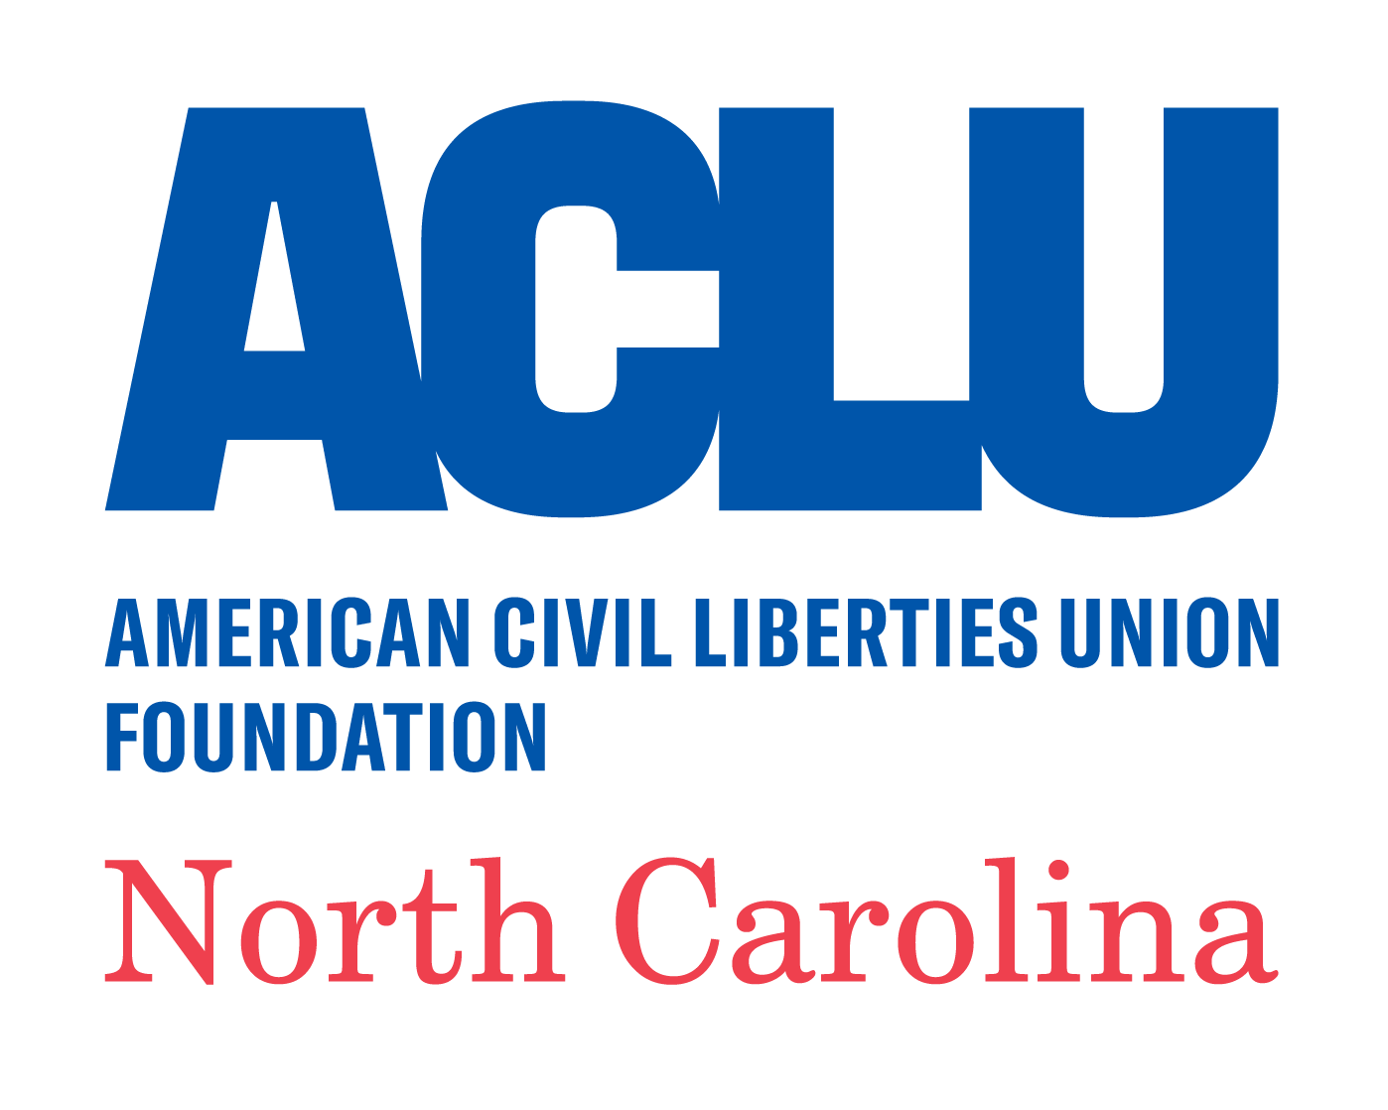
Position: Legal Fellow
Location: Raleigh
Department: Legal
Deadline Date: Application open until position is filled.

The ACLU of North Carolina Legal Foundation (ACLU-NCLF) seeks to sponsor a candidate to apply for full-time, one- or two-year law school-funded public interest legal fellowships to begin work in Fall 2022 (or sooner, if the applicable funding source allows). In limited circumstances, we may consider assisting the candidate in applying for other fellowships such as Skadden or Justice Catalyst, but given our small size and limited capacity to support multiple fellowship applications, our preference is that the candidate apply for law school-based funding in addition to any other fellowship sources.
The Legal Fellow will work to advance one of our major issue areas: criminal law reform, racial justice, LGBTQIA+ equality, reproductive freedom, or the rights of immigrants. Proposed projects often combine litigation and advocacy with community outreach and public education. The candidate will be responsible for identifying potential sources of funding for the proposed fellowship and preparing fellowship application materials with the approval, guidance, and support of ACLU of North Carolina (ACLU-NC) legal staff.

Who We Are
Founded in 1965, the ACLU-NC, an affiliate of the national American Civil Liberties Union, is a private, nonprofit, nonpartisan organization that stands as the state’s guardian of liberty – working in courts, the General Assembly, and communities to protect and advance civil rights and civil liberties for all North Carolinians.
The ACLU-NC brings together litigation, legislative advocacy, communications, and organizing strategies to empower communities and achieve our objectives in major issue

areas including criminal law reform, racial justice, LGBTQIA+ equality, reproductive freedom, and the rights of immigrants. With nearly 30,000 members and supporters across the state, the ACLU-NC has a staff of more than 20 people with a central office in Raleigh and a satellite office in Charlotte.

What You’ll Do

You will help us protect and advance the rights of North Carolinians by:

- Conducting factual investigations to identify policies and practices that can be challenged through litigation, including through court observation, interviews of clients, potential clients, and witnesses, or public records requests.
- Drafting legal memoranda, pleadings, affidavits, motions, and briefs.
- Reviewing and analyzing documents to support litigation and advocacy.
- Participating in discovery and trial practice.
- Providing as-needed legal research, writing, and editing support for ACLU-NCLF.
- Drafting and editing public education and non-litigation advocacy materials.
- Conducting community outreach and know-your-rights presentations.
- Performing occasional administrative work as necessary to support litigation efforts.
- Occasionally traveling for work and working on the weekends and evenings if needed.
- Coordinating and preparing applications for fellowship funding and all reporting needed to sustain or comply with conditions of funding.
- Consulting closely with the ACLU-NCLF throughout the application process.

Who You Are
Our requirements for the person who fills this position are:
- J.D. degree at the start of the fellowship.
- Admission to the North Carolina bar or pending efforts to seek admission to the North Carolina bar at the start of the fellowship.
- Demonstrated commitment to public interest law, civil liberties, and racial justice, and to the mission and goals of the ACLU-NC.
- Excellent research, writing, and verbal communication skills, and ability to explain complex legal concepts in plain language.
- Ability to conduct complex legal analysis and fact-finding in a fast-paced litigation environment.
- Excellent interpersonal skills, including respect for others’ lived experiences, and ability to work and interact respectfully and thoughtfully with people from backgrounds different from your own.
- Ability to work collaboratively as part of a multidisciplinary team of legal staff, communications, policy and advocacy colleagues, as well as in coalition with partner organizations or law firms.
- Self-motivated with the ability to take initiative, manage a variety of tasks, and meet deadlines.
- Ability to think creatively and to use non-litigation strategies to promote objectives is strongly preferred.
- Demonstrated commitment to social justice, equity, and inclusion is required, including a personal approach that values individual lived experience and respects differences of race, ethnicity, nationality, age, gender and gender identity, sexual orientation, religion, ability, and socio-economic circumstances.
- Commitment to working collaboratively and respectfully toward resolving

obstacles and conflicts.
- Excellent computer skills including knowledge of Microsoft Office suite.

What Else Should You Know?
You are welcome here! The ACLU-NC is committed to an inclusive work environment that reflects the population that we serve. We are proud to be an equal opportunity employer and are committed to building an organization where all employees and North Carolinians can be proud. We eagerly anticipate applications from all qualified individuals without regard to race, color, religion, gender, sexual orientation, gender identity or expression, age, national origin, marital status, citizenship, disability, parental status, veteran status, or record of arrest or conviction.
ACLU-NCLF will rely on the fellowship as the primary source of funding for this position but will contribute funds as necessary to bring your salary in line with what we pay similarly situated staff attorneys under our pay scale. ACLU-NCLF attorney salaries start at $60,600 but may change subject to a collective bargaining agreement. We will also provide you with benefits available to similarly-situated permanent employees under an applicable collective bargaining agreement, including health insurance, a 401K plan, and paid holidays, vacation, and sick leave.

To Apply
If you would like to be considered for a sponsorship opportunity, please submit:

- a cover letter explaining your interest in working with the ACLU-NC to advance one of our issue areas and a brief description of a proposed fellowship project or area of focus;
- a resume;
- a legal writing sample (no more than 15 pages long, please);

- a law school transcript; and,
- three professional references.

Your writing sample should be something that you primarily authored and edited, without significant drafting or editing by others.
Materials should be sent to HR@acluofnc.org - please reference “[Your Name] - Legal Fellow” in the subject line. We will review applications on a rolling basis until we have selected a fellowship candidate, but priority consideration may be given to applicants who submit applications by August 2, 2021.
The ACLU-NCLF is an equal opportunity employer. We value a diverse workforce and an inclusive culture. We encourage all qualified individuals to apply -- especially people of color; women; people from low-income backgrounds; people with disabilities; people who identify as LGBTQIA+; and people who are formerly incarcerated or otherwise directly impacted by the criminal legal system.

