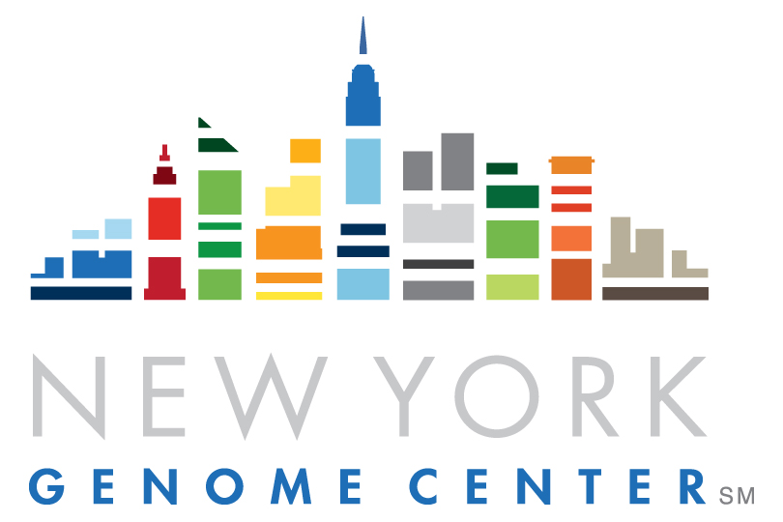

New York Genome Center

Associate Counsel

New York, NY

Position Description
NYGC’s Office of General Counsel (OGC) is seeking an experienced attorney to provide sound, thorough and timely legal advice in support of NYGC’s research and operational objectives. The OGC is responsible for counseling the organization and its leaders across a wide range of substantive legal and regulatory areas, including commercial transactions, data privacy/security, clinical testing, intellectual property, technology transfer, tax exempt status, faculty affairs, employee relations, export controls, and corporate governance. OGC attorneys are expected to become conversant with all of NYGC’s activities and to practice as generalists, with a willingness to learn new subject matter and assume a diverse mix of assignments.

The OGC is a small team headed by NYGC’s Vice President & General Counsel. As a key member of the OGC, the Associate Counsel’s principal responsibilities will include, but are not limited to:

- Draft, review and/or negotiate contractual arrangements of all kinds, including master services agreements, equipment purchase agreements, vendor agreements, software licensing agreements, grant and donor agreements, data and material transfer agreements, loan and financing documents, and personnel agreements.
- Provide counsel on current or proposed federal, state or local laws, or other government measures, that may affect NYGC’s operations. This includes, for example, questions on the application or interpretation of laws related to areas such as privacy and the management of human health information, the conduct of clinical trials or clinical testing, the tax treatment of program revenues, and labor and employment practices.
- Develop policies and procedures to address NYGC’s myriad legal compliance obligations; assist in staff training regarding these obligations.
- Work closely with the finance team to review and prepare NYGC’s annual federal Form 990 tax report, and similar New York state filings.
- Provide practical advice and counsel to NYGC’s human resources professionals on labor and employment issues.
- Help manage NYGC’s intellectual property, including review of invention disclosures, oversight of external patent counsel, communication with faculty inventors, and development and negotiation of corporate sponsored research and technology transfer agreements, all in partnership with NYGC’s Office of Business Development, and as appropriate, with administrators at affiliated academic institutions.
- Assist as needed with NYGC responses to external inquiries or complaints from federal, state or local agencies, or non-governmental parties, that may raise legal or other significant issues for NYGC;
- Review and advise on any legal issues related to external corporate communications;
- Support the activities of NYGC’s institutional development group, including reviewing, preparing and interpreting gift agreements.
- Aid in managing projects assigned to retained outside counsel, including reviewing engagement letters and monthly fee statements.

Position Requirements
- J.D. degree from a leading law school accredited by the American Bar Association;
- Admitted to practice in New York State;
- 7+ years of experience practicing law with at least 3 years at a major research university/hospital, non-profit organization or top-tier law firm required. For law firm candidates, nonprofit, higher education or healthcare experience strongly preferred;
- Science or medical research background, or demonstrated interest in science, preferred;
- Strong transactional experience and business acumen required, as well as excellent contract drafting and negotiation skills;
- Knowledge of data privacy and clinical research laws and regulations helpful;
- Experience with intellectual property issues, including patent law and software licensing, a plus;
- Ability and willingness to handle a variety of tasks across a broad range of substantive areas and to learn new areas quickly;
- Ability to work both independently and collaboratively;
- Strong attention to detail;
- Excellent judgment;
- Superior verbal and written communication and interpersonal skills, and demonstrated success in relating to many different constituencies;
- Highly developed strategic and conceptual/analytical skills;
- Ability to work in a fast-changing, intellectually demanding environment;
- Ability to make decisions and prioritize work with a sensitivity to the importance of the issues and constituencies involved, and to balance information-gathering with timely action.

To Apply

In order to be considered for this position, all applicants must submit a cover letter and resume. Your cover letter should highlight elements of your experience, skills and/or personality that make you a good fit for the position.

Work Flexibility

NYGC has established a flexible work policy to give employees and other staff more ability to balance their work, personal commitments, and commuting challenges. The incumbent in this position is eligible for a flexible work schedule or hybrid work arrangement with supervisory approval.

Competencies
- Technical and Professional Skills: Consistently demonstrates skills and knowledge relevant for current role; strives to expand the depth and breadth of technical and professional skills; works with a high level of integrity; exhibits focus and discipline; appropriately prioritizes, manages expectations and delivers on commitments.
- Collaborative & Communicative: Models collaboration and teamwork; brings out the best in others; effectively works with all levels, internally and externally; respects and embraces diversity of perspective; communicates clearly and listens carefully; uses good judgment as to what to communicate and when to do so.
- Adaptable & Innovative: Adaptable and embraces change; develops new insights and pursues improvements and efficiency; fosters exchange of new ideas and willing to challenge the status quo; takes initiative and is solution-oriented; engages in work with passion and curiosity.

About the New York Genome Center
The New York Genome Center (NYGC) is an independent, nonprofit, academic research organization dedicated to advancing genomic research. NYGC scientists and staff are furthering new approaches to diagnosing and treating neurological diseases and cancer through their unique capabilities in whole genome sequencing, RNA sequencing, state-of-the art analytics, and the development of genomic tools. NYGC concentrates specifically on disease-based research in the following areas: neuropsychiatric disease (autism, schizophrenia, bipolar); neurodegenerative disease (ALS, Alzheimer’s, Parkinson’s, Huntington’s), and cancer.

Located in Lower Manhattan, the New York Genome Center was founded by and remains closely affiliated with the leading academic medical centers and research universities in the New York region, engaging in research projects with and for these institutions. Essential to our collaborative work is an outstanding faculty, whose members typically hold a joint appointment at NYGC and a partner university. They support our scientific mission by conducting independent research in areas of mutual interest to us and the wider scientific community.

Equal Opportunity

Diversity, equity, and inclusion are central to NYGC’s core mission. We strive to create a workplace environment that is welcoming and fair to all regardless of race, ethnicity, gender, sexual orientation, physical ability, or religion. We believe that when people of various backgrounds, life experiences, and perspectives work together in an inclusive and equitable environment, we gain new and valuable perspectives that otherwise would have been missed. Valuing and supporting all NYGC employees as individuals while helping them realize their full potential is critical to promoting greater collaboration, innovation, and discovery – fostering a sense of belonging for our greatest strength, our people. We recognize that there is still work to be done that will require sustained commitment from the entire organization.

The New York Genome Center is a VEVRAA Federal Contractor. All qualified applicants will receive consideration for employment and will not be discriminated against on the basis of race, creed, color, gender, religion, national origin, sexual orientation, age, disability, genetic predisposition or carrier status, protected veteran or military status, domestic violence victim status, partnership status, caregiver status, alienage or citizenship status, marital status, or any other characteristic protected by applicable law. NYGC takes affirmative action in support of its policy to hire and advance in employment individuals who are minorities, women, protected veterans, and individuals with disabilities.

FLSA Status – Exempt
This position is eligible for relocation assistance.
This position is not eligible for visa sponsorship.

Please Apply here

