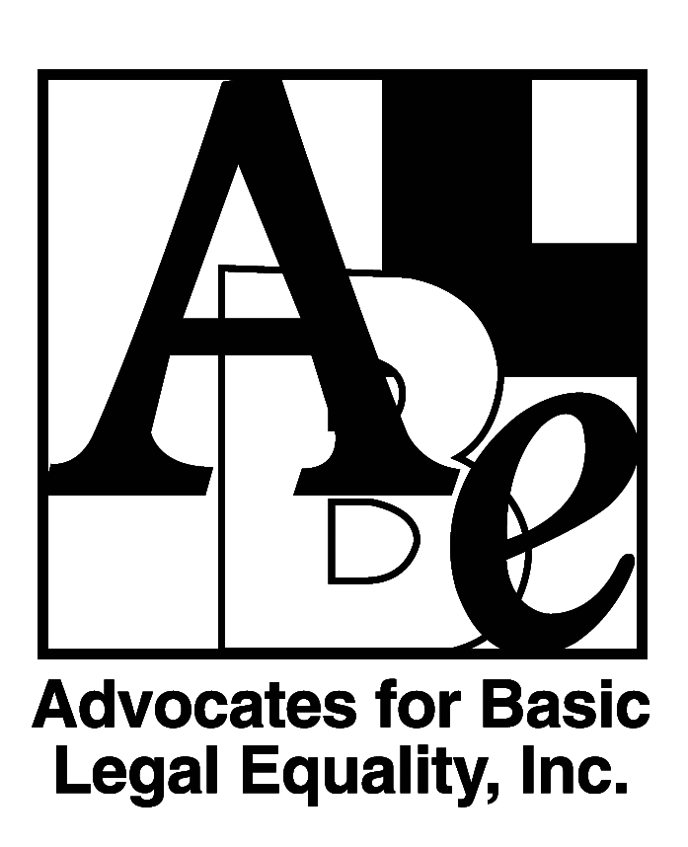
Position Available:
Staff Attorney-
Medical-Legal Partnership for Children
Advocates for Basic Legal Equality, Inc. (ABLE), a non-profit regional law firm that provides high-quality legal assistance to low-income individuals and groups in western Ohio, seeks a resourceful, culturally competent attorney to serve as an advocate for children in poverty with the Medical-Legal Partnership for Children in our Dayton office.
Join the movement to transform public health! The Miami Valley Medical-Legal Partnership for Children combines the strengths of law and medicine to address systemic issues affecting children’s health. The Attorney will represent families and work with healthcare providers in Montgomery County to develop creative strategies to improve health outcomes for children, particularly those affected by the opioid crisis. The project is a collaboration between ABLE, Legal Aid of Western Ohio, Inc., and area children’s hospitals and clinics.
Requirements include:
- Membership in the Ohio Bar or ability to be admitted by motion or temporary certification. The ideal candidate will have at least 1 year of legal experience. Attorneys with recent bar admissions are encouraged to apply.
- Excellent legal, communication, leadership, and interpersonal skills, including working in collaborative and group environments
- Familiarity with community lawyering and advocacy to change systems
- Ability to relate well with and commitment to providing legal services to people with low incomes
Experience in special education, housing, government benefits, family law, or poverty law in general is highly preferred. Competitive salary based on relevant experience; comprehensive fringe benefits, including loan repayment assistance.

To Apply: Submit resume, cover letter, and writing sample at https://www.ablelaw.org/careers-with-able/. Position will remain open until filled.
ABLE is an Equal Opportunity Employer and places a high value on diversity in our workplace, including diversity in race, ethnicity, gender, sexual orientation, age, and physical ability. We strive to create an environment welcoming to all individuals and we encourage applications from individuals traditionally underrepresented in the legal profession. Applicants requiring accommodation for the interview/application process should contact the recruitment coordinator at ablejobs@freelawyers.org.

