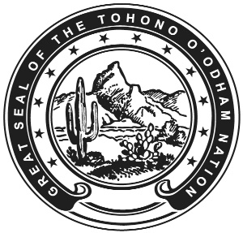

TOHONO O’ODHAM NATION
OFFICE OF ATTORNEY GENERAL
P.O. Box 830 - Sells, Arizona 85634
Telephone (520) 383-3410

POSITION NOTICE
March 2022
The Tohono O’odham Office of Attorney General is hiring a Deputy Attorney General. The Office of Attorney General represents the interests of the Tohono O'odham Nation in tribal, state, and federal venues. Attorneys enjoy a diverse practice, face challenging jurisdictional issues, and protect tribal sovereignty. Knowledge of federal Indian Law is preferred but not necessary.
The Office will consider applicants with a Juris Doctorate from an accredited law school, eight years’ work experience in the legal field or an equivalent combination of training, education and work experience which demonstrates the ability to perform the duties of this position. One year of supervisory experience is required. The salary for this position is $171,129.30.
Requirements include an active Arizona State Bar license, or a Bar Member in another state and Arizona licensing within 18 months of commencement of employment. A valid Arizona driver's license is required, along with consent to have your driving record checked periodically. Applicants must also pass a background check. Indian Preference will be applied.
The Nation offers generous benefits including paid holidays, employer funded retirement plan, sick and annual leave, and low cost medical, dental, and vision insurance.
Please submit a Resume to Eunice Grana, Office Manager, Office of the Attorney General, at Eunice.Grana@tonation-nsn.gov or call Mrs. Grana at (520) 383-3410 if you have any specific questions.
You can submit an application online at Tohono Oodham Nation Jobs or www.tonation-nsn.gov/employment.

