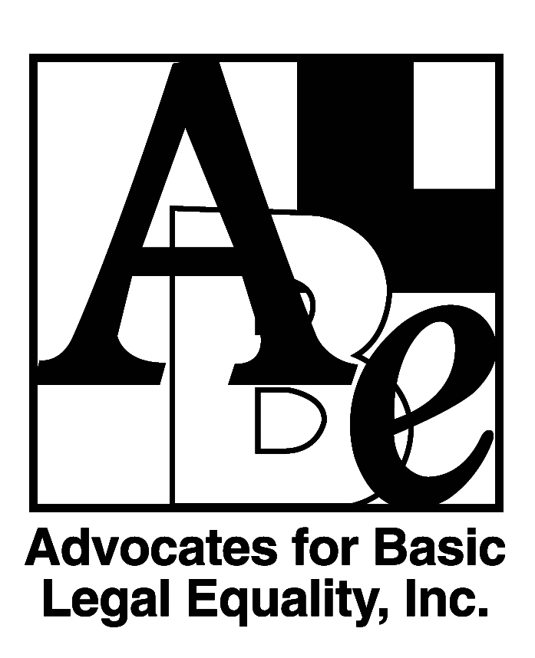
Position Available
Managing Attorney-
Agricultural Worker and Immigrant Rights Practice Group

Advocates for Basic Legal Equality, Inc. (ABLE), a non-profit law firm with a long history of representing low-income clients in Ohio in achieving equal justice and opportunity, seeks an Attorney to lead its Agricultural Worker and Immigrant Rights Practice Group. The position can be based in Toledo or Dayton, Ohio.

The Managing Attorney provides leadership for effective and strategic legal services to meet critical client and community needs. The Managing Attorney will coordinate and manage attorneys and paralegals in ABLE's Agricultural Worker and Immigrant Rights Practice Group. These committed and talented advocates have earned their reputation as among the top immigration advocates statewide, regionally, and nationally. They provide legal representation to agricultural workers and immigrants throughout Ohio in a wide variety of immigration and civil rights cases and proceedings.

The Managing Attorney will:
- Provide leadership, creativity, passion, and inspiration in guiding practice group members in achieving ABLE’s mission.
- Work with practice group members and the Director of Advocacy to develop a practice group work plan designed to have a lasting impact on agricultural worker and immigrant rights and to create equity and justice for agricultural workers and immigrants.
- Effectively supervise legal work within the practice group and mentor new attorneys to ensure all legal work meets ABLE’s high quality standards and meets measurable outcomes established in the practice group and individual work plans.
- Think strategically and view issues from a systemic and impact perspective while managing the practice group’s high-volume caseload.
- Build on the diverse skills, talents, and backgrounds of staff to develop a strong team.
- Manage certain aspects of grant writing and grant reporting to funders supporting the practice group’s work.

The Managing Attorney must demonstrate excellent legal, communication, teamwork, and advocacy skills, administrative leadership, supervisory and mentoring experience, initiative and sound judgment, and the ability to handle and supervise major advocacy projects. The ideal applicant has practical knowledge and experience in immigration, civil rights, and employment law; and an understanding of the socio-cultural issues experienced by people living in poverty. The Managing Attorney must have excellent interpersonal skills and be experienced in working in collaborative and group environments.

Minimum of five years of immigration legal experience required. Regular travel required. Membership in Ohio Bar or ability to be admitted by motion or temporary certification is required; experience with case management software and Microsoft Office (Outlook, Word, Excel, PowerPoint, etc.). Ability to relate well with clients living in poverty. Ability to communicate fluently in Spanish is valued at ABLE. Strong record of cultural competence and cross-cultural communication skills is required. A sense of humor and collegiality are also highly valued.

Salary depends on relevant legal experience. Excellent fringe benefits, including health insurance and student loan repayment assistance up to $6000 per year through the Ohio Access to Justice Foundation. Remote work is likely, but court hearings, meetings with community partners, and client-based work in person is required.

To Apply: Please visit https://www.ablelaw.org/careers-with-able to submit your application. Position will remain open until filled.

ABLE is an Equal Opportunity Employer and places a high value on diversity in our workplace, including diversity in race, ethnicity, gender, sexual orientation, age, and physical ability. We strive to create an environment welcoming to all individuals and we encourage applications from individuals traditionally underrepresented in the legal profession. Applicants requiring accommodation for the interview/application process should contact the recruitment coordinator at ablejobs@freelawyers.org.

