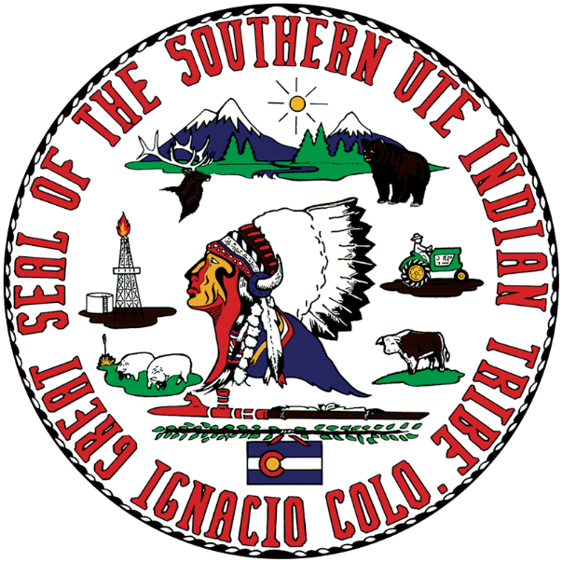

Southern Ute Indian Tribe

Job Announcement
Tribal Attorney

The Southern Ute Indian Tribe is looking for a self-motivated, personable, disciplined, and compassionate attorney to join the in-house Legal Department on the Southern Ute Indian Reservation in sunny, mountainous, southwest Colorado. The Legal Department provides legal representation, advice, and support to the Tribal government. The team of well-established tribal attorneys work together on a broad range of projects, including filing briefs in the U.S. Supreme Court, negotiating intergovernmental agreements, drafting comments on proposed legislation, and supporting tribal initiatives and services. The work is exciting, interesting, fulfilling, and challenging. A strong command of Federal Indian law and understanding of tribal sovereignty in this position is essential, as is an ability to provide legal advice on a variety of topics in a fast-paced environment. This position requires a minimum of three years of full-time experience practicing law, including significant Indian law experience.
For more information about the position and to apply, please visit: https://careers.southernute.com/pfund.
The position is open until filled.

