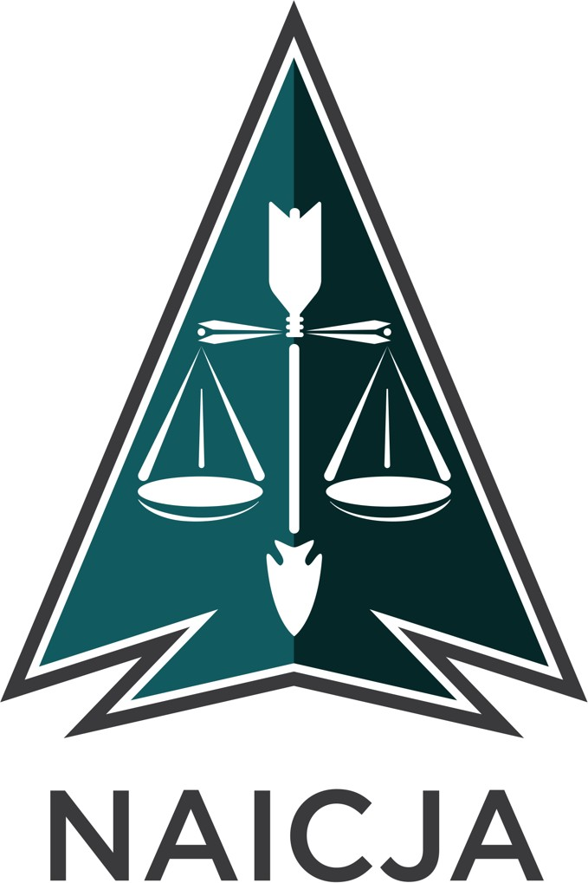**NATIONAL AMERICAN INDIAN COURT JUDGES ASSOCIATION**

**SERVING TRIBAL JUSTICE SYSTEMS SINCE 1969**

1942 BROADWAY, SUITE 321 / BOULDER, CO 80302 | **PHONE** 303.449.4112 | **FAX** 303.449.4038

**POSITION ANNOUNCEMENT**

**Job Title:** Program Attorney **Location:** Boulder, CO **Closing Date: May 16, 2025**

# Summary:

The National American Indian Court Judges Association (NAICJA), established in 1969, is a non-profit membership organization dedicated to supporting and promoting tribal justice systems through technical assistance and training. NAICJA also works to further the public knowledge and understanding of tribal justice systems. NAICJA’s training and technical assistance program is the National Tribal Justice Resource Center (“NTJRC”) located in Boulder, Colorado. Each year NAICJA hosts the National Tribal Judicial and Court Clerks Conference which provides tribal judges, justice system personnel, and others interested in tribal justice systems current information about new legal and practice developments and the opportunity to network and engage in peer-to-peer consultation.

# Salary:

Salary depends on qualifications and available funding. Other benefits includes, medical, dental, vision, and disability insurance, PTO, sick-leave, flex-work, cell-phone reimbursement, and reimbursement for professional fees for licenses and training.

# Primary Duties:

NAICJA seeks an experienced Program Attorney responsible for researching, designing and implementing continuing judicial education programs. Under direction of the Academic Director the Program Attorney will:

1. Manage and oversee federal grants, including supervision of Program Coordinator.
2. Oversee the coordination of grant and project deliverables.
3. Monitor and ensure grant reporting deadlines are met and grant deliverables are completed.
4. Research, design and implement curricula for in-person and web-based trainings.
5. Identify and recruit judicial, medical, legal, and other professional faculty.
6. Develop faculty, provide feedback on performance and presentation style.
7. Edit faculty-provided material for accuracy and compliance with NAICJA standards.
8. Lead manager/administrator team during all stages of course facilitation.
9. Assist with development and administrative matters as needed.
10. Handle all logistics for on-site trainings including direct contact with host site staff.
11. Participate in grant concept papers and applications, including deliverable identification, budgeting time and expenditures, and project length. Ensures deliverables are met.
12. Assist Executive Director with development of yearly program budgets.
13. Assist in all areas of the Training and Technical Assistance and special projects as required.
14. Continually uphold the NAICJA values of maintaining an absolute commitment to justice, delivering and inspiring excellence and innovation in our work, championing integrity, and demonstrating engaged leadership.
15. Facilitating the convening of the Annual National Tribal Judicial and Court Clerks Conference.
16. Supporting NAICJA Board of Directors.
17. Additional assigned duties related to current NAICJA projects.

**Qualifications**:

**Education and/or Experience**:

*Required*:

* Juris Doctorate (J.D.)
* Substantial previous experience with American Indian and Alaska Native persons, communities and/or tribal justice systems
* Background in training and technical assistance for tribal audiences
* Experience in administering federal grants
* Demonstrated experience managing budgets and producing financial reports
* Strong ability to conduct outreach and manage large networks of partners
* Experience in a management position and/or demonstrated ability to oversee staff
* Must be in good standing with all jurisdictions where admitted to practice law

*Strongly preferred*:

* Experience authoring successful grant proposals desirable
* Experience working with a non-profit organization desirable
* Advanced understanding of federal Indian law and tribal legal systems
* Understanding of holistic defense and traditional dispute resolution models

# Language/Writing Skills:

Must possess strong written communication skills, including excellent grammar, spelling and proofreading skills. Strong computer skills required including proficiency in Internet- based research, Microsoft Office applications, budgetary software (especially Quick Books) and familiarity with or willingness to learn process for updating NTJRC website.

# Communication/Presentation Skills:

1. Must possess strong oral communication skills. Demonstrated ability to communicate orally to a variety of audiences. Ability to present educational workshops for tribal nations and organizations on issues pertaining to related projects. Proven ability to communicate in a culturally sensitive environment

# Other Requirements:

Travel is required. Must possess and maintain a valid driver’s license. Must undergo and pass a criminal background check.

# How to Apply:

Submit via email, a cover letter, resume, one writing sample, and three references to:

Hon. Carrie Garrow

President, Board of Directors

National American Indian Court Judges Association Email: [president@naicja.org](mailto:president@naicja.org)

A. Nikki Borchardt Campbell Executive Director

National American Indian Court Judges Association Email: [nikki@naicja.org](mailto:nikki@naicja.org)